**Synthetic Microfiber Destruction Proposal**

Microfibers are small synthetic fibers that are less than 10 micrometers in length. The issue of microfibers is very serious and affects humans as well as our ecosystem. The food we eat, the water we drink; everything is impacted by humanity’s usage of synthetic fibers. These fibers can bind to flame retardants and pesticides to form complex small molecules that we ingest in our water. They also can be taken up by fish and be spread to its predators along the food chain, such as humans.

One major source of microfibers is from washing machine waste water. During agitation of clothing in a washer, microfiber pieces can be shed into waste water. The two main types of synthetic fibers, chemically, are polyesters and polyamides.

Within these types, the most common form of polyester in clothing is Polyethylene terephthalate (PET). It has the following structure:

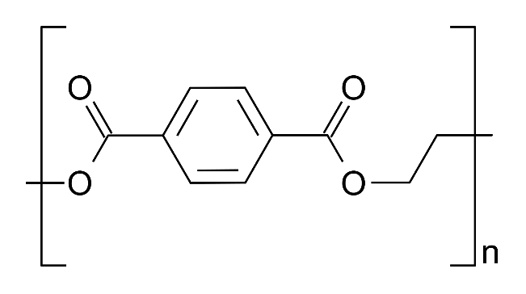

The 2 most common polyamides are Nylon 6 and Nylon 6,6. The structure of Nylon 6 is:

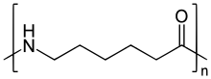

The structure of Nylon 6,6 is:

Nylon 6,6.png

My colleague Matt Eckelmeyer had an interesting idea. Why not use a compartment or area to hold the water that comes out of a washing machine? In this area, we could use some form of lactic acid bacteria to create an acidic environment. This acidic environment in warm water temperatures should assist in the hydrolysis of both polyamides and polyesters.

Once these compounds are broken into smaller substituents, we could attempt to scavenge the smaller pieces to store in our lactic acid bacteria. To scavenge, we must use genetic engineering to get a highly-specific ABC transporter into the microbe membrane. To know what type of solute protein we would need for this ABC transporter we can possibly utilize computational chemistry docking softwares to optimize the chemistry and structure of a potential solute protein.

Once the microfiber monomers are brought into lactic acid bacteria, we can add large pieces of pure zinc and let stir inside this compartment to bind with lactic acid bacteria. Finally, we can filter out the zinc particles (containing bound lactic acid bacteria) which have microfiber monomers inside.